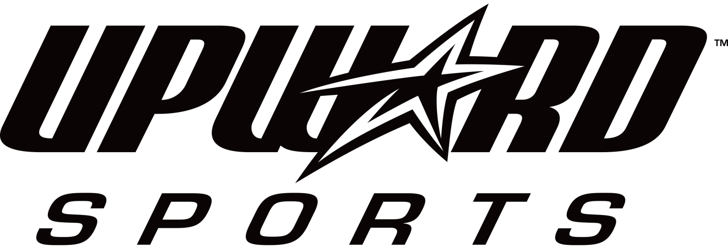

Northern Cincinnati Upward Sports Scholarship Program
Northern Cincinnati Upward Sports provides registration fee scholarships to local athletes, who without this financial assistance would not otherwise be able to participate. The Northern Cincinnati Upward Sports Scholarship Assistance program focuses on providing opportunities for our area youth to participate in basketball and cheerleading for the spiritual, physical, mental, and character training benefits that this program can provide. Scholarship assistance will be dependent upon the funds available and the actual need shown.
Please be aware that Northern Cincinnati Upward Sports Financial Assistance Funds are limited! Our primary goal is to help as many young athletes that we possibly can. Due to the severity to the continuing economic crisis, we anticipate a large number of requests for assistance this season. In an effort to help out as many families as we can with the knowledge that there are limited funds, we are asking those of you that can afford to utilize our option of monthly installments rather than receiving a scholarship to please do so.
To make payment arrangements, contact basketball@cincyupward.org or mail completed form to Faith Community UMC, 8230 Cox Road, WC, OH 45069 attn: Upward scholarship. Rather than offering maximum scholarships (80%), we would like to offer more partial scholarships to help out more families in need this season. Awards of assistance are NOT guaranteed to every applicant.
Requirements for eligibility:
- Commitment to attend a minimum of 80% of scheduled practices and games.
- Participation by a family member in at least one (1) volunteer opportunity during the scholarship season.
- Application must be completed by a parent, guardian, or head of household, with all requested information provided. (Incomplete applications will not be considered.)

Priority will be given to eligible youth meeting one or more of the criteria below:
- Member of a multi-child family.
- Living in a single parent home.
- Receiving assistance from programs such as: Food Stamps, Medicaid, SSI, Foster Care, WIC, etc. (Must provide written documentation of participation in these programs to receive priority status)
- Written recommendation by school representatives, social workers, youth community center workers, or other social services representatives.
- If you or your child has made efforts to save or earn money for the season, please mention it in a letter. Your child’s letter or parent letter should discuss his or her love of the sport and how the applicant believes this will help him/her to achieve life goals.

NOTE: Approval process of a scholarship assistance request does not register the participant for Northern Cincinnati Upward Sports. You will still need to complete all registration documents and attend an evaluation/clinic.

